Oregon Horse Rescue
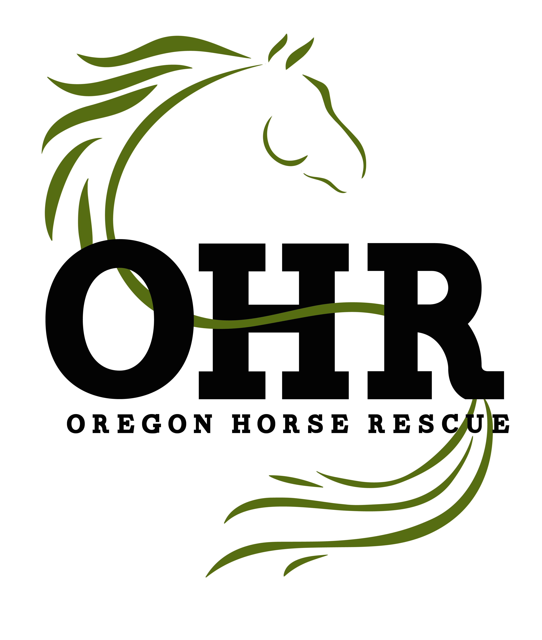4325 Commerce St, STE 111-463
Eugene, OR 97402
OregonHorseRescue.com OregonHorseRescueAndRehab@gmail.com

ADOPTION APPLICATION
Please do not leave any blank spaces – write N.A. if the item is not applicable to you.
Adopter’s Full Name: __________________________________________________________ Address: _____________________________________________________________________ Mailing Address (if different): ____________________________________________________
Phone: ___________________________Cell Phone: __________________________________ Email Address: ________________________________
Date of Birth: __________________ Height: _______Weight:____________
Male: ___ Female: ___ Ages of Children who may ride: ____________________
What other pets or animals do you have?_____________________________________________

Current Employer: __________________________
Address/Phone of Employer: _____________________________________________________
How long have you been employed there? ____________
Do you and/or your household make over $25,000 per year? Yes___ No ___
How long have you lived at your current address? _____
Do you own your property? Yes___ No__
If renting what is the name and contact number of your landlord?_________________________

Will the horse be kept at your residence Yes___ No ___
If Yes, how many other horses are on the property? _____
Do you own a stallion? If yes would he be contained away from any mares?_______________
How many fenced acres is your property? __________
Please describe the facilities including the type of fencing, barn or shelter; please include size of stall and/or shelter and typical living arrangement (if horses predominately live in or out etc.) and please attach pictures to this application or scan them and email to OregonHorseRescueAndRehab@gmail.com

If the horse will be boarded please name facility: ______________________________________ Boarding facility address and/or website & email: _______________________________________ Boarding facility phone number: ______________
Describe (type of facility, fencing, stall and/or pasture size and cost of board):

HORSE EXPERIENCE
Have you owned a horse before? Yes___ No___
Please describe your experience: ___________________________________________________

Do you currently own horse(s)? Yes ___ No ___
If yes, please describe: ________________________________________________________

If you ride, which discipline do you participate in? (Type of showing, trail riding, pleasure,
recreational riding, English or western etc.): _________________________________________
How long have you been riding? ___________
Do you have a Trainer or Instructor? If yes, please name: ______________________________
Do you have a horse you are interested in? If yes please name: __________________________
If No please provide the following: Breed preference: _____________ Height range: ________
Sex preference: Gelding____ Mare____ Preferred age of Horse: _______
What is your intended use of the equine? ___________________________________________
Pasture pet/companion animal?_________ Showing: ______Trail riding/recreational:_______
Please provide specific show discipline or additional details: ___________________________
Will anyone other than you be riding the horse? __________________________________
Who will care for the horse while you are away? _____________________________________

Veterinarian’s Name & Contact Information: _______________________________________
Farrier’s Name & Contact Information: _____________________________________________
Have you ever been charged with animal cruelty or domestic violence? Yes____ No____
Have you ever surrendered an animal to a rescue agency in the past?_____ If so please describe
circumstance: __________________________________________________________________
Note: We may at our discretion conduct criminal background checks

Please list 3 references, other than family members (Please provide names, addresses, telephone numbers, relationship and e-mail address)
1.
2.
3.

I have read and agree with the terms and conditions outlined in the Oregon Horse Rescue
adoption contract and understand this application does not constitute approval for
adoption.
I certify that all information provided on this application is true and accurate to the best of my knowledge.
Signature ____________________________
Print Name ___________________________ Date: __________
Received by OHR Representative: ___________________________ Date: _______

